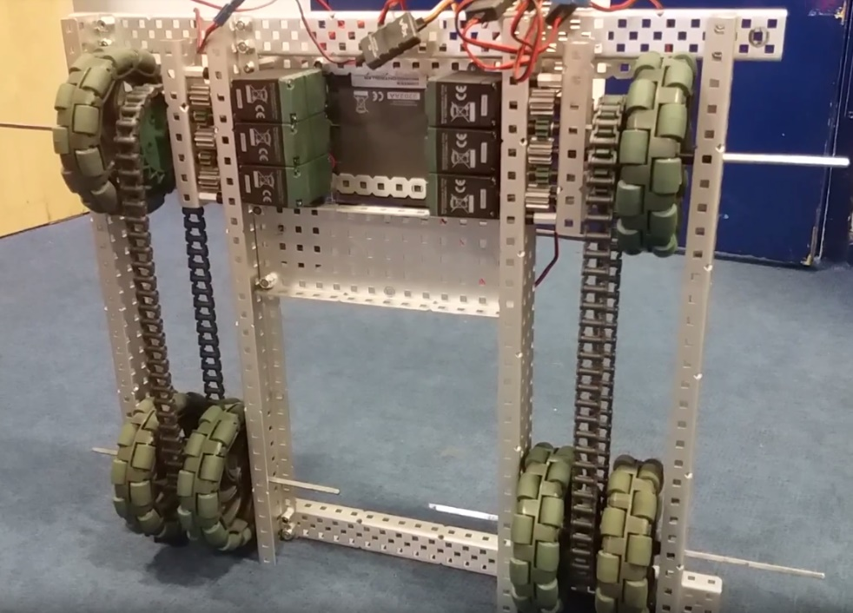

**What needs to be changed:**

* Fix axel squeaking problem (move or lubricate)
* Move motor and gear system in by one notch
* Build to full specifications

**WHAT HAS BEEN CHANGED:**

N/A

By Robbie Buxton

19/20/2017 – 18:23

**Overview:**

This is the first version of our base and robot. It is built to a slightly smaller specification the we will use in the end due to not wanting to start cutting metal before we are certain with the design. At the moment, we are experimenting with a drive train system. This is because we found in the prior challenge that if not on a driver chain motor tend to get in the way of things and can cause intake problems. We have also decided to use at least 6 motors on our base due to the fact that we think we do not need any more than 5 motors for our lifting system. 2 on the primary lift. 2 on the secondary and 1 on the claw (More on that later). After testing the system briefly, we have come to the conclusion that general system works however some of the gear axles need their position to be slightly tweaked as they are causing squeaking. We also think that it would be beneficial to try and move the motors and the gear system in by one bar to try and reduce space.

SPECIFICATIONS:

* 6 Motor HS drive
* Two drive chains
* 6 wheels
* Aluminium structure

DIMENTIONS:

Fill in

Robot Base V 0.01